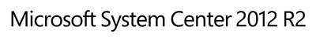

Guide for System Center Management Pack for Windows Server 2012 and Windows Server 2012 R2 DHCP
Microsoft Corporation
Published: November 2018
Send feedback or suggestions about this document to mpgfeed@microsoft.com. Please include the management pack guide name with your feedback.
The Operations Manager team encourages you to provide feedback on the management pack by providing a review on the management pack’s page in the Management Pack Catalog (http://go.microsoft.com/fwlink/?LinkID=82105).

Copyright
This document is provided "as-is". Information and views expressed in this document, including URL and other Internet Web site references, may change without notice.
Some examples depicted herein are provided for illustration only and are fictitious. No real association or connection is intended or should be inferred.
This document does not provide you with any legal rights to any intellectual property in any Microsoft product. You may copy and use this document for your internal, reference purposes. You may modify this document for your internal, reference purposes.
© 2016 Microsoft Corporation. All rights reserved.
Microsoft, Active Directory, Bing, BizTalk, Forefront, Hyper-V, Internet Explorer, JScript, SharePoint, Silverlight, SQL Database, SQL Server, Visio, Visual Basic, Visual Studio, Win32, Windows, Windows Azure, Windows Intune, Windows PowerShell, Windows Server, and Windows Vista are trademarks of the Microsoft group of companies. All other trademarks are property of their respective owners.

Contents
Introduction to the DHCP Management Pack 5
What's New – November 2018 5
What's New – September 2017 5
What's New – December 2016 5
What's New – August 2016 5
What's New – november 2015 5
What's New – September 2015 5
What's New – August 2014 6
What's New – October 2013 6
What's New – May 2013 6
Supported Configurations 7
What this Management Pack Monitors 7
Discoveries 7
Groups 8
Classes 9
Monitors 10
Collection Rules 22
Recommended Additional Management Packs 35
Security Considerations 35
Low-Privilege Environments 35
Windows Server DHCP Management Pack Discovery 36
Classes 37
How Health Rolls Up 37
Key Monitoring Scenarios 42
Known Issues and Troubleshooting 44
Links 50

Introduction to the DHCP Management Pack
This guide describes the Windows Server 2012 and Windows Server 2012 R2 DHCP Management Pack for System Center, version 6.0.7309.0. The management pack is used to monitor the Dynamic Host Configuration Protocol (DHCP) server role of Windows Server 2012 and Windows Server 2012 R2.

What's New – November 2018
The following bugs have been fixed in the Management Pack:
- DHCP 2012 Scopes Discovery failing to discover the scopes for large number of scopes.
- Added New monitor for monitoring large number of scopes as a single unit and task for generating critical scopes report.

What's New – SEPTEMBER 2017
The following bugs have been fixed in the Management Pack:
- DHCP Failover Server Relationship Discovery was failing as the Scope ID length max limit was 4000. The Scope ID length limit has been increased to 65536.
- Alert description for "DHCP IPv4 Runtime Service Bound to Static IP Address Monitor”, "DHCP Dependent Service Health Monitor", "DHCP Database Integrity Monitor” have been updated, users can comprehend and troubleshoot the situation better with such information.
- To reduce the alert noise created with multiple alerts of same type, the alert rules “DHCP Back Up Database Warning Rule”, “DHCP IPv4 Runtime DNS Registration Rule”,” DHCP IPv4 Runtime Users Group Configuration Rule” and “DHCP Database Integrity Warning Rule” are suppressed so that only the alert count increases and not generate new alerts
- "Collect ALL DHCP Server Performance Data" rule has been fixed to ingest right data in the registry key, thus indicating the correct health state of the entity
- "DHCP Performance Health Monitor" which was always in not-monitored state has been rectified to correctly show the health state of the entity it monitors
- "DHCP Server 2012 R2 Super Scope Addresses Available Percentage Monitor" that was failing to change state on critical alerts, has been fixed to show the appropriate state so the users do not miss out on critical state.

What's New – December 2016
- Added “Known Issues and Troubleshooting” section to the guide.
- Updated “Supported Configurations” section of the guide.
The following bugs have been fixed in the Management Pack:
- “DHCP Server 2016 IPV4 Individual Scope Addresses Available Percentage Monitor” was not generating the corresponding alerts in case of 0% percentage available.
- “DHCP Server 2016 IPV4 Individual Scope Addresses Available Percentage Monitor” was failing if multiple scopes had the same name.
- “DHCP Server 2016 IPV6 Individual Scope Addresses Available Percentage Monitor” was not generating the corresponding alerts in case of 0% percentage available.
- “DHCP Server 2016 IPV6 Individual Scope Addresses Available Percentage Monitor” was failing if multiple scopes had the same name.

What's New – August 2016
The following bugs have been fixed in the Management Pack:
- If the property scope id length of the failover server watcher class exceeded the max length, then Failover Server Watcher was not being discovered and hence could not monitor DHCP failover servers. The fix ensures that discovery is successful.
- In a DHCP server with multiple scopes, if two or more scopes have same name when the alert raise for one scope it automatically raises the alert for another same scope name. The fix ensures that alerts are sent only for generated scope.

What's New – november 2015
The following bug has been fixed in the Management Pack:
- In a DHCP server with multiple scopes, if the first scope exceeds the threshold for minimum available addresses, alerts are sent for all scopes on the DHCP server even for the ones that don't violate the threshold. The fix ensures that alerts are sent only for the scope exceeding the threshold.

What's New – September 2015
The following bug has been fixed in the Management Pack:
- The properties view of Failover Server Relationship does not display all the IP addresses, with this fix the properties view of Failover Server Relationship will display all IP addresses.

What's New – August 2014
The Management Pack contains the following new features:
- Added Event 1044 to DHCPDatabase Integrity Monitor to Success State
- Changed Monitor "DHCP Back Up Database Error Monitor" to have criteria for Healthy or to be Rule Based (it is Manual Reset)
  - Disabled the Unit Monitor Microsoft.Windows.DHCPServer.Library.Database.UnitMonitor.BackupAndRestore.1
  - Adding 2 rules to cover Warning and Error events.
- Change Monitor "DHCP IPv4 Runtime DNS Registration Monitor" to have criteria for Healthy or to be Rule Based
  - Disabled the Unit Monitor ID: Microsoft.Windows.DHCPServer.Library.IPv4Runtime.UnitMonitor.DNSRegistration
- Monitor "DHCP IPv4 Runtime Authorization Needed Monitor" never returns to green state
  - Adding Event ID 1044 to Healthy State expression
- Add dependency monitor to DHCP 2012 R2 Servers group

What's New – October 2013
The Management Pack contains the following new features:
• Windows Server 2012 R2 supported.
• For Windows Server 2012 R2, the consumption of the IP address range and the availability of DHCP service can be monitored.

What's New – May 2013
The Management Pack contains the following new features:
• All workflows are implemented using PowerShell to improve overall functionality for this Management Pack.
• Failover Relationships are now a supported configuration that is being discovered and monitored by the new 2012 Management Pack.
• Discovery and Monitoring of a DHCP Cluster installation.
• Scopes, super scopes utilization is being monitored based on events that provide 80% and 100% usage.
• Utilization of scopes based on policies, client packet drop and residual IP addresses range monitoring.

Supported Configurations
The Management Pack for System Center supports primarily the DHCP server role of Microsoft Windows Server 2012 and 2012 R2, the DHCP clustered installation and the failover relationship feature. Windows PowerShell feature should be enabled.
All SCOM management servers should have remote access to the event log of the servers participated in DHCP failover relationship. For details, see “Event log” section of the following article.
Operating system | Standalone DHCP |  | Clustered DHCP
 | (x64) | (x86) | (x64) | (x86)
Microsoft Windows Server 2012 | X | NA | X | NA
Microsoft Windows Server 2012 R2 | X | NA | X | NA
This management pack is supported to run in Operations Manager 2007 R2, System Center 2012 Operations Manager and System Center 2012 Operations Manager SP1.

What this Management Pack Monitors
The following tables list the elements of this management pack:

Discoveries

DISCOVERIES | Description | Method
Microsoft.Windows.DHCPServer.2012.Server.Discovery | Discovers DHCP Server based on the installed DHCP feature. | PowerShell Script based
Microsoft.Windows.DHCPServer.2012.ClusterServer.Discovery | Discovers DHCP Server based on the installed DHCP Failover Cluster feature. | PowerShell Script based
Microsoft.Windows.DHCPServer.2012.Scopes.Discovery | Discovers DHCP IPV4 and IPV6 scopes | PowerShell Script based
Microsoft.Windows.DHCPServer.2012.Database.Discovery | Discovers DHCP database | PowerShell Script based
Microsoft.Windows.DHCPServer.2012.FailoverServerWatcher.Discovery | Discovers DHCP Failover relationships defined between Servers | PowerShell Script based
Microsoft.Windows.DHCPServer.2012.R2.Server.Discovery | Discovers DHCP Server based on the installed DHCP feature. | PowerShell Script based
Microsoft.Windows.DHCPServer.2012.R2.ClusterServer.Discovery | Discovers DHCP Server based on the installed DHCP Failover Cluster feature. | PowerShell Script based
Microsoft.Windows.DHCPServer.2012.R2.Scopes.Discovery | Discovers DHCP IPV4 and IPV6 scopes | PowerShell Script based
Microsoft.Windows.DHCPServer.2012.R2.Database.Discovery | Discovers DHCP database | PowerShell Script based
Microsoft.Windows.DHCPServer.2012.R2.FailoverServerWatcher.Discovery | Discovers DHCP Failover relationships defined between Servers | PowerShell Script based

Groups
GROUPS | Description | Method
Microsoft.Windows.DHCPServer.2012.Group.Servers | Populate with DHCP 2012 servers | Group Populator Module
Microsoft.Windows.DHCPServer.2012.Group.IPv4Scopes | Populate with DHCP 2012 IPV4 Scopes | Group Populator Module
Microsoft.Windows.DHCPServer.2012.Group.IPv6Scopes | Populate with DHCP 2012 IPV6 Scopes | Group Populator Module
Microsoft.Windows.DHCPServer.2012.FailoverServerWatchersGroup | Populate with DHCP 2012 Failover Server Relationships | Group Populator Module
Microsoft.Windows.DHCPServer.2012.R2.Group.Servers | Populate with DHCP 2012 R2 servers | Group Populator Module
Microsoft.Windows.DHCPServer.2012.R2.Group.IPv4Scopes | Populate with DHCP 2012 R2 IPV4 Scopes | Group Populator Module
Microsoft.Windows.DHCPServer.2012.R2.Group.IPv6Scopes | Populate with DHCP 2012 R2 IPV6 Scopes | Group Populator Module
Microsoft.Windows.DHCPServer.2012.R2.FailoverServerWatchersGroup | Populate with DHCP 2012 R2 Failover Server Relationships | Group Populator Module
Microsoft.Windows.DHCPServer.2012.R2.Group.Superscopes | Populate with DHCP 2012 R2 Super Scopes | Group Populator DS

Classes

CLASSES | Purpose | Notes
Microsoft.Windows.DHCPServer.2012.Server | The class represents the DHCP server service and its functional state. | The base class is a Windows Computer Role.
Microsoft.Windows.DHCPServer.2012.IPv4Scope | The class represents the DHCP IPV4 scopes defined in a DHCP 2012 server and its functional state. | The base class is Windows Application component.
Microsoft.Windows.DHCPServer.2012.IPv6Scope | The class represents the DHCP IPV6 scopes defined in a DHCP 2012 server and its functional state. | The base class is Windows Application component.
Microsoft.Windows.DHCPServer.2012.IPv6Runtime | This class represents an IPV6 installation that is defined in the DHCP 2012 Server, and its Role functional state. | The base class is Windows Application component.
Microsoft.Windows.DHCPServer.2012.FailoverServerWatcher | This class represents a Failover Server relationship defined in a DHCP 2012 Server and its functional state | This base class is system perspective
Microsoft.Windows.DHCPServer.2012.R2.Server | The class represents the DHCP server service and its functional state. | The base class is a Windows Computer Role.
Microsoft.Windows.DHCPServer.2012.R2.IPv4Scope | The class represents the DHCP IPV4 scopes defined in a DHCP 2012 R2 server and its functional state. | The base class is Windows Application component.
Microsoft.Windows.DHCPServer.2012.R2.IPv6Scope | The class represents the DHCP IPV6 scopes defined in a DHCP 2012 R2 server and its functional state. | The base class is Windows Application component.
Microsoft.Windows.DHCPServer.2012.R2.IPv6Runtime | This class represents an IPV6 installation that is defined in the DHCP 2012 R2 Server, and its Role functional state. | The base class is Windows Application component.
Microsoft.Windows.DHCPServer.2012.R2.FailoverServerWatcher | This class represents a Failover Server relationship defined in a DHCP 2012 R2 Server and its functional state | This base class is system perspective

Monitors

MONITORS | Condition Detected | Troubleshooting
Microsoft.Windows.DHCPServer.Library.  Database.UnitMonitor.BackupAndRestore.1  (Defined in DHCP Library) | Detects failure of DHCP system’s restoration of the database | Repair the database and restore from a known good backup.
Microsoft.Windows.DHCPServer.Library.  Database.UnitMonitor.BackupAndRestore.2  (Defined in DHCP Library) | DHCP failed to find and back up the database | Create a valid backup path and restore the database
Microsoft.Windows.DHCPServer.Library.  Database.UnitMonitor.DBIntegrity  (Defined in DHCP Library) | DHCP has detected inconsistencies in the Jet database | Repair database and restore from a known good backup
Microsoft.Windows.DHCPServer.Library.  IPv4Runtime.UnitMonitor.ActiveDirectory  (Defined in DHCP Library) | DHCP cannot contact the domain because the directory service or domain controller is unavailable. | Fix any network connectivity problems between the DHCP server and domain controller
Microsoft.Windows.DHCPServer.Library.  IPv4Runtime.UnitMonitor.Backup  (Defined in DHCP Library) | DHCP was unable to restore the server registry configuration. | Give SYSTEM read/write permissions to the backup/restore directory
Microsoft.Windows.DHCPServer.Library.  IPv4Runtime.UnitMonitor.Communications  (Defined in DHCP Library) | DHCP could not find the domain to which it is joined. | Identify and fix any network connectivity problems
Microsoft.Windows.DHCPServer.Library.  IPv4Runtime.UnitMonitor.GeneralAvailability.1  (Defined in DHCP Library) | DHCP has encountered an exception to the DLL callout. | Restart the DHCP Server service
Microsoft.Windows.DHCPServer.Library.  IPv4Runtime.UnitMonitor.GeneralAvailability.2  (Defined in DHCP Library) | DHCP is unavailable because it cannot find the domain, load its DLLs, or gain authorization. | Authorize the DHCP server
Microsoft.Windows.DHCPServer.Library.  IPv4Runtime.UnitMonitor.GeneralAvailability.3  (Defined in DHCP Library) | DHCP is unavailable because it cannot find the domain, load its DLLs, or gain authorization. | Assign execute rights to the DLL
Microsoft.Windows.DHCPServer.Library.  IPv4Runtime.UnitMonitor.LeaseIssuance  (Defined in DHCP Library) | DHCP was unable to ping the client before leasing an IP address. | Reconfigure reservations or exclusion ranges
Microsoft.Windows.DHCPServer.Library.  Database.UnitMonitor.DatabaseCorrupt  (Defined in DHCP Library) | DHCP failed to initialize one of its components. | Restore the DHCP database from a known good backup
Microsoft.Windows.DHCPServer.2012.  IPv6Runtime.InitializationFailed  (Defined in DHCP 2012) | DHCP service failed to initialize. The server cannot initialize until it has a static IPv6 address configured and proper configuration parameters. | Restart the DHCP Server service
Microsoft.Windows.DHCPServer.2012.  IPv6Runtime.UnitMonitor.ScopeFull  (Defined in DHCP 2012) | DHCP has determined that a scope is nearing capacity. If the scope becomes full, the DHCP server cannot lease additional IP addresses. | Extend DHCP scopes, reduce lease times, or decrease cleanup interval
Microsoft.Windows.DHCPServer.2012.R2.  IPv6Runtime.InitializationFailed  (Defined in DHCP 2012 R2) | DHCP service failed to initialize. The server cannot initialize until it has a static IPv6 address configured and proper configuration parameters. | Restart the DHCP Server service
Microsoft.Windows.DHCPServer.2012.R2.  IPv6Runtime.UnitMonitor.ScopeFull  (Defined in DHCP 2012 R2) | DHCP has determined that a scope is nearing capacity. If the scope becomes full, the DHCP server cannot lease additional IP addresses. | Extend DHCP scopes, reduce lease times, or decrease cleanup interval
Microsoft.Windows.DHCPServer.Library.  IPv4Scope.UnitMonitor.BOOTPScopeFull  (Defined in DHCP Library) | DHCP has determined that there are no IP addresses available for BOOTP clients in the scope. | Extend DHCP scopes, reduce lease times, or decrease cleanup interval
Microsoft.Windows.DHCPServer.Library.  IPv4Scope.UnitMonitor.LeaseAvailability.2  (Defined in DHCP Library) | DHCP has determined that a scope is nearing capacity | Extend DHCP scopes, reduce lease times, or decrease cleanup interval
Microsoft.Windows.DHCPServer.Library.  Database.UnitMonitor.Migration.1  (Defined in DHCP Library) | DHCP has determined that the database being used in this migration is incompatible with the DHCP version you are using. | Re-create the DHCP database export and retry the import
Microsoft.Windows.DHCPServer.Library.  IPv4Runtime.UnitMonitor.BOOTPFileConfig  (Defined in DHCP Library) | DHCP was unable to read the BOOTP file table from the registry. | Create or add entries to the BOOTP table
Microsoft.Windows.DHCPServer.Library.  IPv4Runtime.UnitMonitor.DHCPServiceBoundToStaticIP  (Defined in DHCP Library) | DHCP has no static IP address and cannot service clients until one is configured. | Configure a static address for the DHCP server
Microsoft.Windows.DHCPServer.Library.  IPv4Runtime.UnitMonitor.DNSRegistration  (Defined in DHCP Library) | DHCP failed to impersonate the credentials necessary for DNS registrations and dynamic DNS updates. | Configure impersonation credentials for dynamic updates
Microsoft.Windows.DHCPServer.Library.  IPv4Runtime.UnitMonitor.GroupConfig  (Defined in DHCP Library) | DHCP was unable to find or create the DHCP Users group or the DHCP Administrators local group. | Restart the DHCP Server service
Microsoft.Windows.DHCPServer.Library.  IPv4Runtime.UnitMonitor.ServiceInitialization.1  (Defined in DHCP Library) | The DHCP service failed to initialize. The server cannot initialize until it has a static IP address configured and proper configuration parameter | Restart the DHCP Server service
Microsoft.Windows.DHCPServer.Library.  IPv4Runtime.UnitMonitor.ServiceInitialization.2  (Defined in DHCP Library) | The DHCP service failed to initialize. The server cannot initialize until it has a static IP address configured and proper configuration parameters. | Configure a static IP address for the DHCP server
Microsoft.Windows.DHCPServer.2012.  IPv6Runtime.UnitMonitor.StaticIPAssigned  (Defined in DHCP 2012) | DHCP failed to initialize one of its components. | Configure a static IP address for the DHCP server
Microsoft.Windows.DHCPServer.2012.R2.  IPv6Runtime.UnitMonitor.StaticIPAssigned  (Defined in DHCP 2012 R2) | DHCP failed to initialize one of its components. | Configure a static IP address for the DHCP server
Microsoft.Windows.DHCPServer.Library.Server.UnitMonitor.DependentServiceHealth  (Defined in DHCP Library) | DHCP cannot initialize because one or more services that it depends on failed. | Disable the Winsock Proxy client on the DHCP server  Restart the DHCP Server service
Microsoft.Windows.DHCPServer.Library.  UnitMonitor.DHCPServiceRunning  (Defined in DHCP Library) | DHCP failed to initialize one of its components | Restart the DHCP Server service
Microsoft.Windows.DHCPServer.Library.  IPv4Scope.UnitMonitor.OrphanedEntry  (Defined in DHCP Library) | DHCP has orphaned database entries due to the deletion of a class or an option definition. | Reconcile the DHCP scope
Microsoft.Windows.DHCPServer.Library.  IPv4Scope.UnitMonitor.UnknownScopeOption  (Defined in DHCP Library) | DHCP received an unknown option from a client. | Configure DHCP options on the server to match the client
Microsoft.Windows.DHCPServer.Library.  IPv4Runtime.UnitMonitor.Auditing.1  (Defined in DHCP Library) | DHCP has determined that the audit log cannot be written to because it is full or cannot be accessed. | Edit audit log path
Microsoft.Windows.DHCPServer.Library.  IPv4Runtime.UnitMonitor.Auditing.2  (Defined in DHCP Library) | DHCP has determined that the audit log cannot be written to because it is full or cannot be accessed. | Edit audit log path  Remove old audit log files or increase the maximum audit log size.  Give the DHCP service account permissions to audit log files and folders.
Microsoft.Windows.DHCPServer.Library.  IPv4Runtime.UnitMonitor.Auditing.3  (Defined in DHCP Library) | DHCP has determined that the audit log cannot be written to because it is full or cannot be accessed. | Give the DHCP service account permissions to audit log files and folders
Microsoft.Windows.DHCPServer.Library.  IPv4Runtime.UnitMonitor.AuthorizationAndConflicts  (Defined in DHCP Library) | DHCP has determined that the server is unauthorized to lease to clients on the domain or that there is a conflict with another authorized DHCP server in the workgroup. | Authorize the DHCP server or remove other active DHCP servers
Microsoft.Windows.DHCPServer.Library.  IPv4Runtime.UnitMonitor.RogueDetection.1  (Defined in DHCP Library) | DHCP has detected another DHCP server on the network. | Authorize the DHCP server
Microsoft.Windows.DHCPServer.Library.  IPv4Runtime.UnitMonitor.RogueDetection.2  (Defined in DHCP Library) | DHCP cannot authorize the server. The server must be authorized in Active Directory Domain Services. | Identify and fix any network connectivity problems
Microsoft.Windows.DHCPServer.2012.  IPv6Runtime.UnitMonitor.Auditing  (Defined in DHCP 2012) | DHCPv6 has determined that the audit log cannot be written to because it is full or cannot be accessed. | Remove old audit log files or increase the maximum audit log size
Microsoft.Windows.DHCPServer.2012.Scope.  IPV4.FreeScopeAddresses.Percentage.Monitor  (Defined in DHCP 2012) | DHCP has determined that a scope is nearing capacity | Extend DHCP scopes, reduce lease times, or decrease cleanup interval
Microsoft.Windows.DHCPServer.2012.Scope.  IPV4.FreeScopeAddresses.Quantity.Monitor  (Defined in DHCP 2012) | DHCP has determined that a scope is nearing capacity | Extend DHCP scopes, reduce lease times, or decrease cleanup interval
Microsoft.Windows.DHCPServer.2012.Scope.  IPV6.FreeScopeAddresses.Percentage.Monitor  (Defined in DHCP 2012) | DHCP has determined that a scope is nearing capacity | Extend DHCP scopes, reduce lease times, or decrease cleanup interval
Microsoft.Windows.DHCPServer.2012.Scope.  IPV6.FreeScopeAddresses.Quantity.Monitor  (Defined in DHCP 2012) | DHCP has determined that a scope is nearing capacity | Extend DHCP scopes, reduce lease times, or decrease cleanup interval
Microsoft.Windows.DHCPServer.2012.FailoverServerWatcher.UnitMonitor.State  (Defined in DHCP 2012) | The reported state of the DHCP Failover Relationship Server changed to Not Healthy | Identify and fix any network connectivity problems
Microsoft.Windows.DHCPServer.2012.FailoverServerWatcher.UnitMonitor.OutOfTimeSync  (Defined in DHCP 2012) | The DHCP Failover Relationship Server was unable to ping the Partner Server to synchronize it | Identify and fix any network connectivity problems
Microsoft.Windows.DHCPServer.2012.FailoverServerWatcher.UnitMonitor.ErrorCommunicationWithfailoverPartnerServer  (Defined in DHCP 2012) | The DHCP Failover Relationship Server was unable to ping the Partner Server | Identify and fix any network connectivity problems
Microsoft.Windows.DHCPServer.2012.FailoverServerWatcher.UnitMonitor.LostCommunicationWithfailoverPartnerServer  (Defined in DHCP 2012) | The DHCP Failover Relationship Server was unable to ping the Partner Server | Identify and fix any network connectivity problems
Microsoft.Windows.DHCPServer.2012.Scopes.UnitMonitor.UtilizationByScope  (Defined in DHCP 2012) | DHCP has determined that a scope is nearing capacity | Extend DHCP scopes, reduce lease times, or decrease cleanup interval
Microsoft.Windows.DHCPServer.2012.ScopesAndSuperScopes.UnitMonitor.Utilization  (Defined in DHCP 2012) | DHCP has determined that a scope is nearing capacity | Extend DHCP scopes, reduce lease times, or decrease cleanup interval
Microsoft.Windows.DHCPServer.2012.Policy.  UnitMonitor.IPAddressRange80Full  (Defined in DHCP 2012) | DHCP has determined that a scope is nearing capacity | Extend DHCP scopes, reduce lease times, or decrease cleanup interval
Microsoft.Windows.DHCPServer.2012.Policy.  UnitMonitor.IPAddressRange100Full  (Defined in DHCP 2012) | DHCP has determined that a scope is nearing capacity | Extend DHCP scopes, reduce lease times, or decrease cleanup interval
Microsoft.Windows.DHCPServer.2012.Policy.  UnitMonitor.ClientPackDrop100Full  (Defined in DHCP 2012) | DHCP has determined that a scope is nearing capacity | Extend DHCP scopes, reduce lease times, or decrease cleanup interval
Microsoft.Windows.DHCPServer.2012.Policy.  UnitMonitor.ResidualIPAddressRange80Full  (Defined in DHCP 2012) | DHCP has determined that a scope is nearing capacity | Extend DHCP scopes, reduce lease times, or decrease cleanup interval
Microsoft.Windows.DHCPServer.2012.Policy.  UnitMonitor.ResidualIPAddressRange100Full  (Defined in DHCP 2012) | DHCP has determined that a scope is nearing capacity | Extend DHCP scopes, reduce lease times, or decrease cleanup interval
Microsoft.Windows.DHCPServer.2012.R2.  IPv6Runtime.UnitMonitor.Auditing  (Defined in DHCP 2012) | DHCPv6 has determined that the audit log cannot be written to because it is full or cannot be accessed. | Remove old audit log files or increase the maximum audit log size
Microsoft.Windows.DHCPServer.2012.R2.Scope.  IPV4.FreeScopeAddresses.Percentage.Monitor  (Defined in DHCP 2012) | DHCP has determined that a scope is nearing capacity | Extend DHCP scopes, reduce lease times, or decrease cleanup interval
Microsoft.Windows.DHCPServer.2012.R2.Scope.  IPV4.FreeScopeAddresses.Quantity.Monitor  (Defined in DHCP 2012) | DHCP has determined that a scope is nearing capacity | Extend DHCP scopes, reduce lease times, or decrease cleanup interval
Microsoft.Windows.DHCPServer.2012.R2.Scope.  IPV6.FreeScopeAddresses.Percentage.Monitor  (Defined in DHCP 2012) | DHCP has determined that a scope is nearing capacity | Extend DHCP scopes, reduce lease times, or decrease cleanup interval
Microsoft.Windows.DHCPServer.2012.R2.Scope.  IPV6.FreeScopeAddresses.Quantity.Monitor  (Defined in DHCP 2012) | DHCP has determined that a scope is nearing capacity | Extend DHCP scopes, reduce lease times, or decrease cleanup interval
Microsoft.Windows.DHCPServer.2012.R2.FailoverServerWatcher.UnitMonitor.State  (Defined in DHCP 2012) | The reported state of the DHCP Failover Relationship Server changed to Not Healthy | Identify and fix any network connectivity problems
Microsoft.Windows.DHCPServer.2012.R2.FailoverServerWatcher.UnitMonitor.OutOfTimeSync  (Defined in DHCP 2012) | The DHCP Failover Relationship Server was unable to ping the Partner Server to synchronize it | Identify and fix any network connectivity problems
Microsoft.Windows.DHCPServer.2012.R2.FailoverServerWatcher.UnitMonitor.ErrorCommunicationWithfailoverPartnerServer  (Defined in DHCP 2012) | The DHCP Failover Relationship Server was unable to ping the Partner Server | Identify and fix any network connectivity problems
Microsoft.Windows.DHCPServer.2012.R2.FailoverServerWatcher.UnitMonitor.LostCommunicationWithfailoverPartnerServer  (Defined in DHCP 2012) | The DHCP Failover Relationship Server was unable to ping the Partner Server | Identify and fix any network connectivity problems
Microsoft.Windows.DHCPServer.2012.R2.Scopes.UnitMonitor.UtilizationByScope  (Defined in DHCP 2012) | DHCP has determined that a scope is nearing capacity | Extend DHCP scopes, reduce lease times, or decrease cleanup interval
Microsoft.Windows.DHCPServer.2012.R2.ScopesAndSuperScopes.UnitMonitor.Utilization  (Defined in DHCP 2012) | DHCP has determined that a scope is nearing capacity | Extend DHCP scopes, reduce lease times, or decrease cleanup interval
Microsoft.Windows.DHCPServer.2012.R2.Policy.  UnitMonitor.IPAddressRange80Full  (Defined in DHCP 2012) | DHCP has determined that a scope is nearing capacity | Extend DHCP scopes, reduce lease times, or decrease cleanup interval
Microsoft.Windows.DHCPServer.2012.R2.Policy.  UnitMonitor.IPAddressRange100Full  (Defined in DHCP 2012) | DHCP has determined that a scope is nearing capacity | Extend DHCP scopes, reduce lease times, or decrease cleanup interval
Microsoft.Windows.DHCPServer.2012.R2.Policy.  UnitMonitor.ClientPackDrop100Full  (Defined in DHCP 2012) | DHCP has determined that a scope is nearing capacity | Extend DHCP scopes, reduce lease times, or decrease cleanup interval
Microsoft.Windows.DHCPServer.2012.R2.Policy.  UnitMonitor.ResidualIPAddressRange80Full  (Defined in DHCP 2012) | DHCP has determined that a scope is nearing capacity | Extend DHCP scopes, reduce lease times, or decrease cleanup interval
Microsoft.Windows.DHCPServer.2012.R2.Policy.  UnitMonitor.ResidualIPAddressRange100Full  (Defined in DHCP 2012) | DHCP has determined that a scope is nearing capacity | Extend DHCP scopes, reduce lease times, or decrease cleanup interval
Microsoft.Windows.DHCPServer.2012.R2.  IPv6Runtime.UnitMonitor.Auditing  (Defined in DHCP 2012) | DHCPv6 has determined that the audit log cannot be written to because it is full or cannot be accessed. | Remove old audit log files or increase the maximum audit log size
Microsoft.Windows.DHCPServer.2012.R2.Scope.  IPV4.FreeScopeAddresses.Percentage.Monitor  (Defined in DHCP 2012) | DHCP has determined that a scope is nearing capacity | Extend DHCP scopes, reduce lease times, or decrease cleanup interval
Microsoft.Windows.DHCPServer.2012.R2.Scope.  IPV4.FreeScopeAddresses.Quantity.Monitor  (Defined in DHCP 2012) | DHCP has determined that a scope is nearing capacity | Extend DHCP scopes, reduce lease times, or decrease cleanup interval
Microsoft.Windows.DHCPServer.2012.R2.Scope.  IPV6.FreeScopeAddresses.Percentage.Monitor  (Defined in DHCP 2012) | DHCP has determined that a scope is nearing capacity | Extend DHCP scopes, reduce lease times, or decrease cleanup interval
Microsoft.Windows.DHCPServer.2012.R2.Scope.  IPV6.FreeScopeAddresses.Quantity.Monitor  (Defined in DHCP 2012) | DHCP has determined that a scope is nearing capacity | Extend DHCP scopes, reduce lease times, or decrease cleanup interval
Microsoft.Windows.DHCPServer.2012.R2.FailoverServerWatcher.UnitMonitor.State  (Defined in DHCP 2012) | The reported state of the DHCP Failover Relationship Server changed to Not Healthy | Identify and fix any network connectivity problems
Microsoft.Windows.DHCPServer.2012.R2.FailoverServerWatcher.UnitMonitor.OutOfTimeSync  (Defined in DHCP 2012) | The DHCP Failover Relationship Server was unable to ping the Partner Server to synchronize it | Identify and fix any network connectivity problems
Microsoft.Windows.DHCPServer.2012.R2.FailoverServerWatcher.UnitMonitor.ErrorCommunicationWithfailoverPartnerServer  (Defined in DHCP 2012) | The DHCP Failover Relationship Server was unable to ping the Partner Server | Identify and fix any network connectivity problems
Microsoft.Windows.DHCPServer.2012.R2.FailoverServerWatcher.UnitMonitor.LostCommunicationWithfailoverPartnerServer  (Defined in DHCP 2012) | The DHCP Failover Relationship Server was unable to ping the Partner Server | Identify and fix any network connectivity problems
Microsoft.Windows.DHCPServer.2012.R2.Scopes.UnitMonitor.UtilizationByScope  (Defined in DHCP 2012) | DHCP has determined that a scope is nearing capacity | Extend DHCP scopes, reduce lease times, or decrease cleanup interval
Microsoft.Windows.DHCPServer.2012.R2.ScopesAndSuperScopes.UnitMonitor.Utilization  (Defined in DHCP 2012) | DHCP has determined that a scope is nearing capacity | Extend DHCP scopes, reduce lease times, or decrease cleanup interval
Microsoft.Windows.DHCPServer.2012.R2.Policy.  UnitMonitor.IPAddressRange80Full  (Defined in DHCP 2012) | DHCP has determined that a scope is nearing capacity | Extend DHCP scopes, reduce lease times, or decrease cleanup interval
Microsoft.Windows.DHCPServer.2012.R2.SuperScope.IPV4.AddressesAvailable.Percentage.Monitor | The percentage of free addresses for the specified super scope fall below the defined threshold. | Extend DHCP scopes, reduce lease times, or decrease cleanup interval
Microsoft.Windows.DHCPServer.2012.AllIndScope.IPV4.FreeScopeAddresses.Percentage.Monitor | The percentage of free addresses for all the Scopes | Extend DHCP scopes, reduce lease times, or decrease cleanup interval

Collection Rules
COLLECTION RULES | Purpose
Microsoft.Windows.DHCPServer.Library.  Database.Collect.BackupPathFail  (Defined in DHCP Library) | DHCP database backup
Microsoft.Windows.DHCPServer.Library.  Database.Collect.CleanupComplete  (Defined in DHCP Library) | DHCP database cleanup completed.
Microsoft.Windows.DHCPServer.Library.  Database.Collect.CleanupStarted  (Defined in DHCP Library) | DHCP database cleanup started.
Microsoft.Windows.DHCPServer.Library.  Database.Collect.ConversionInProgress  (Defined in DHCP Library) | DHCP database conversion in progress
Microsoft.Windows.DHCPServer.Library.  Database.Collect.ConversionRequired  (Defined in DHCP Library) | DHCP database conversion is required
Microsoft.Windows.DHCPServer.Library.  Database.Collect.DatabaseBackupFail  (Defined in DHCP Library) | Database backup failed
Microsoft.Windows.DHCPServer.Database.  Collect.DBCleanup  (Defined in DHCP Library) | DHCP database cleanup
Microsoft.Windows.DHCPServer.Library.  Database.Collect.DBLoadFail  (Defined in DHCP Library) | Failure in loading of database
Microsoft.Windows.DHCPServer.Library.  Database.Collect.DBPathFail  (Defined in DHCP Library) | Failure in database path
Microsoft.Windows.DHCPServer.Library.  Database.Collect.InitFail  (Defined in DHCP Library) | Database initialization failure
Microsoft.Windows.DHCPServer.Library.  Database.Collect.JetErrors  (Defined in DHCP Library) | Jet database errors
Microsoft.Windows.DHCPServer.Library.  Database.Collect.JetWarnings  (Defined in DHCP Library) | Jet database warnings
Microsoft.Windows.DHCPServer.Library.  Database.Collect.RestoreCompleted  (Defined in DHCP Library) | Database restoration completed
Microsoft.Windows.DHCPServer.Library.  Database.Collect.RestoreFailed  (Defined in DHCP Library) | Database restoration failure
Microsoft.Windows.DHCPServer.Library.  IPv4Runtime.Collect.AuditLogAppendFailed  (Defined in DHCP Library) | DHCP audit log append failure
Microsoft.Windows.DHCPServer.Library.  IPv4Runtime.Collect.AuditLogInitFailed  (Defined in DHCP Library) | DHCP audit log initialization failure
Microsoft.Windows.DHCPServer.Library.  IPv4Runtime.Collect.AuditLogMoveFailed  (Defined in DHCP Library) | DHCP audit log move failure
Microsoft.Windows.DHCPServer.Library.  IPv4Runtime.Collect.AuthorizedAndStarted  (Defined in DHCP Library) | DHCP server service is authorized and started
Microsoft.Windows.DHCPServer.Library.  IPv4Runtime.Collect.BadAuditPath  (Defined in DHCP Library) | DHCP is unable to access the audit file path
Microsoft.Windows.DHCPServer.Library.  IPv4Runtime.Collect.BOOTPFileFailed  (Defined in DHCP Library) | DHCP cannot read the DHCP BOOTP file table from the registry
Microsoft.Windows.DHCPServer.Library.  IPv4Runtime.Collect.CalloutLoadException  (Defined in DHCP Library) | The installed callout dll file causes an exception
Microsoft.Windows.DHCPServer.Library.  IPv4Runtime.Collect.CalloutLoadFailed  (Defined in DHCP Library) | DHCP fails to load a callout dll
Microsoft.Windows.DHCPServer.IPv4Runtime.Collect.CalloutLoadSuccess  (Defined in DHCP Library) | Callout dll is loaded successfully
Microsoft.Windows.DHCPServer.Library.  IPv4Runtime.Collect.ClientCleanup  (Defined in DHCP Library) | error occurs on cleaning up pending client records
Microsoft.Windows.DHCPServer.Library.  IPv4Runtime.Collect.ConfigBackup  (Defined in DHCP Library) | error occurs backing up the registry
Microsoft.Windows.DHCPServer.Library.  IPv4Runtime.Collect.DHCPLocalGroupFailed  (Defined in DHCP Library) | DHCP cannot create or read the DHCP local users group
Microsoft.Windows.DHCPServer.Library.  IPv4Runtime.Collect.DomainAuthorized  (Defined in DHCP Library) | DHCP is authorized in the domain
Microsoft.Windows.DHCPServer.Library.  IPv4Runtime.Collect.DomainAuthorizedAndStarted  (Defined in DHCP Library) | DHCP is authorized in the domain and is servicing clients
Microsoft.Windows.DHCPServer.Library.  IPv4Runtime.Collect.DomainError  (Defined in DHCP Library) | DHCP cannot locate the domain
Microsoft.Windows.DHCPServer.Library.  IPv4Runtime.Collect.DomainNotAuthorized  (Defined in DHCP Library) | DHCP is not authorized in the domain
Microsoft.Windows.DHCPServer.Library.  IPv4Runtime.Collect.DomainUnauthorized  (Defined in DHCP Library) | DHCP is not authorized in the domain
Microsoft.Windows.DHCPServer.Library.  IPv4Runtime.Collect.DomainUnchecked  (Defined in DHCP Library) | DHCP has not determined domain authorization
Microsoft.Windows.DHCPServer.Library.  IPv4Runtime.Collect.DomainUpgraded  (Defined in DHCP Library) | DHCP was recently upgraded and domain authorized to start
Microsoft.Windows.DHCPServer.Library.  IPv4Runtime.Collect.DSFailed  (Defined in DHCP Library) | DHCP could not contact a domain controller
Microsoft.Windows.DHCPServer.Library.  IPv4Runtime.Collect.DynamicAddress  (Defined in DHCP Library) | DHCP detects a dynamic IP address
Microsoft.Windows.DHCPServer.Library.  IPv4Runtime.Collect.GlobalBOOTPFileName  Failed  (Defined in DHCP Library) | DHCP failed to read the global BOOTP filename from the registry
Microsoft.Windows.DHCPServer.Library.  IPv4Runtime.Collect.InitFailed  (Defined in DHCP Library) | DHCP fails to initialize its configuration parameter
Microsoft.Windows.DHCPServer.Library.  IPv4Runtime.Collect.InterfaceNotificationFailed  (Defined in DHCP Library) | DHCP detects an interface notification problem
Microsoft.Windows.DHCPServer.IPv4Runtime.Collect.NetworkFailure  (Defined in DHCP Library) | Network failure
Microsoft.Windows.DHCPServer.Library.  IPv4Runtime.Collect.OtherServer  (Defined in DHCP Library) | DHCP workgroup server detects a domain server
Microsoft.Windows.DHCPServer.Library.  IPv4Runtime.Collect.PingFailed  (Defined in DHCP Library) | DHCP was unable to ping for a new address
Microsoft.Windows.DHCPServer.Library.  IPv4Runtime.Collect.RegistryRestoreFailed  (Defined in DHCP Library) | Error occurs while restoring the DHCP registry configuration
Microsoft.Windows.DHCPServer.Library.  IPv4Runtime.Collect.RogueServerDetected  (Defined in DHCP Library) | DHCP detects an unauthorized DHCP server on the same network
Microsoft.Windows.DHCPServer.Library.  IPv4Runtime.Collect.Upgraded  (Defined in DHCP Library) | DHCP was recently upgraded and authorized to start
Microsoft.Windows.DHCPServer.Library.  IPv4Runtime.Collect.WinsockFailed  (Defined in DHCP Library) | Winsock initialization fails
Microsoft.Windows.DHCPServer.Library  .IPv4Runtime.CollectCalloutFailed  (Defined in DHCP Library) | Exception occurs on calling out to the installed callout dll file
Microsoft.Windows.DHCPServer.Library.  IPv4Runtime.CollectNotAuthorized  (Defined in DHCP Library) | DHCP server is not authorized to start
Microsoft.Windows.DHCPServer.Library.  IPv4Runtime.CollectUnauthorized  (Defined in DHCP Library) | DHCP is unauthorized
Microsoft.Windows.DHCPServer.Library.  IPv4Runtime.CollectWrongDNSCreds  (Defined in DHCP Library) | DHCP cannot use the credentials provided for DNS registrations
Microsoft.Windows.DHCPServer.Library.  IPv4Runtime.NoCredsOnDC  (Defined in DHCP Library) | DHCP is running on a domain controller but does not have specific credentials for registering DNS information
Microsoft.Windows.DHCPServer.Library.  IPv4Runtime.SBSOtherServer  (Defined in DHCP Library) | SBS DHCP server detects another DHCP server
Microsoft.Windows.DHCPServer.Library.Rule.  CollectPerformanceData  (Defined in DHCP Library) | Collects all DHCP Performance Data
Microsoft.Windows.DHCPServer.Library.Server.Collect.DDNSUpdateRequest  (Defined in DHCP Library) | DDNS update is requested
Microsoft.Windows.DHCPServer.Library.Server.Collect.DDNSUpdateSuccess  (Defined in DHCP Library) | DDNS update successfully completes
Microsoft.Windows.DHCPServer.Library.Server.Collect.DHCPNotBoundToStaticIPAddress  (Defined in DHCP Library) | DHCP service is not servicing any clients because none of the active network interfaces have statically configured IP addresses, or there are no active interfaces.
Microsoft.Windows.DHCPServer.Library.Server.Collect.InitDataFailed  (Defined in DHCP Library) | DHCP is unable to initialize its global parameters
Microsoft.Windows.DHCPServer.Library.Server.Collect.InitRegistryFailed  (Defined in DHCP Library) | DHCP server failed to initialize its registry parameters
Microsoft.Windows.DHCPServer.Library.Server.Collect.RegistrationFailure  (Defined in DHCP Library) | DHCP service could not register with the Service Controller
Microsoft.Windows.DHCPServer.Library.Server.Collect.RPCFail  (Defined in DHCP Library) | DHCP server failed to start as a RPC server
Microsoft.Windows.DHCPServer.Library.Server.Collect.ScriptTraceEvents  (Defined in DHCP Library) | DHCP server script based events
Microsoft.Windows.DHCPServer.Library.Server.Collect.WinsockFailed  (Defined in DHCP Library) | DHCP server failed to initialize its Winsock data
Microsoft.Windows.DHCPServer.Library.Server.PerformanceCollection.AcksPerSecond  (Defined in DHCP Library) | DHCP server performance monitor - DHCP Acks Per Second
Microsoft.Windows.DHCPServer.Library.Server.PerformanceCollection.ActiveQueueLength  (Defined in DHCP Library) | DHCP server performance monitor - DHCP Active Queue Length
Microsoft.Windows.DHCPServer.Library.Server.PerformanceCollection.ConflictCheckQueue  Length  (Defined in DHCP Library) | DHCP server performance monitor - DHCP Conflict Check Queue Length
Microsoft.Windows.DHCPServer.Library.Server.PerformanceCollection.DeclinesPerSecond  (Defined in DHCP Library) | DHCP server performance monitor - DHCP Declines / Second
Microsoft.Windows.DHCPServer.Library.Server.PerformanceCollection.DiscoversPerSecond  (Defined in DHCP Library) | DHCP server performance monitor - DHCP Discovers / Second
Microsoft.Windows.DHCPServer.Library.Server.PerformanceCollection.DuplicatesDroppedPerSecond  (Defined in DHCP Library) | DHCP server performance monitor - DHCP Duplicates Dropped / Second
Microsoft.Windows.DHCPServer.Library.Server.PerformanceCollection.InformsPerSecond  (Defined in DHCP Library) | DHCP server performance monitor - DHCP Informs / Second
Microsoft.Windows.DHCPServer.Library.Server.PerformanceCollection.MillisecondsPerPacketAvg  (Defined in DHCP Library) | DHCP server performance monitor - DHCP Average Milliseconds / Packet
Microsoft.Windows.DHCPServer.Library.Server.PerformanceCollection.NacksPerSecond  (Defined in DHCP Library) | DHCP server performance monitor - DHCP Nacks / Second
Microsoft.Windows.DHCPServer.Library.Server.PerformanceCollection.OffersPerSecond  (Defined in DHCP Library) | DHCP server performance monitor - DHCP Offers / Second
Microsoft.Windows.DHCPServer.Library.Server.PerformanceCollection.PacketsExpiredPer  Second  (Defined in DHCP Library) | DHCP server performance monitor - DHCP Packets Expired / Second
Microsoft.Windows.DHCPServer.Library.Server.PerformanceCollection.PacketsReceivedPer  Second  (Defined in DHCP Library) | DHCP server performance monitor - DHCP Packets Received / Second
Microsoft.Windows.DHCPServer.Library.Server.PerformanceCollection.ReleasesPerSecond  (Defined in DHCP Library) | DHCP server performance monitor - DHCP Releases / Second
Microsoft.Windows.DHCPServer.Library.Server.PerformanceCollection.RequestsPerSecond  (Defined in DHCP Library) | DHCP server performance monitor - DHCP Requests / Second
Microsoft.Windows.DHCPServer.Library.Server.Collect.DHCPInitialized  (Defined in DHCP Library) | DHCP server service Initialization
Microsoft.Windows.DHCPServer.Library.  IPv4Scope.Collect.LeaseDeclined  (Defined in DHCP Library) | Lease declined
Microsoft.Windows.DHCPServer.Library.  IPv4Scope.Collect.LowAddressWarning  (Defined in DHCP Library) | IPv4 scopes that are running low on available leases
Microsoft.Windows.DHCPServer.Library.  IPv4Scope.Collect.NACKIssued  (Defined in DHCP Library) | IPv4 NACK Issued
Microsoft.Windows.DHCPServer.Library.  IPv4Scope.Collect.ScopeFull  (Defined in DHCP Library) | IPv4 scopes that are out of available leases
Microsoft.Windows.DHCPServer.Library.  IPv4Scope.Collect.UnknownOption  (Defined in DHCP Library) | IPv4 DHCP client requests that contained a request for an unknown DHCP option
Microsoft.Windows.DHCPServer.Library.  IPv4Scope.CollectBOOTPFull  (Defined in DHCP Library) | IPv4 BOOTP requests that could not be filled due to lack of available addresses
Microsoft.Windows.DHCPServer.Library.  IPv4Scope.CollectLeaseRelease  (Defined in DHCP Library) | Released IPv4 leases
Microsoft.Windows.DHCPServer.Library.  IPv4Scope.CollectOrphanedEntriesDeleted  (Defined in DHCP Library) | orphaned entries deleted in the configuration due to the deletion of a class or option definition
Microsoft.Windows.DHCPServer.2012.Scope.  IPV4.CollectFreeScopeAddresses  (Defined in DHCP 2012) | Collects IPV4 Free Scope Addresses
Microsoft.Windows.DHCPServer.2012.Scope.  IPV6.CollectFreeScopeAddresses  (Defined in DHCP 2012) | Collects IPV6 Free Scope Addresses
Microsoft.Windows.DHCPServer.2012.Scope.  IPV4.CollectScopeAddressesInUse  (Defined in DHCP 2012) | Collects IPV4 Scope Addresses In Use
Microsoft.Windows.DHCPServer.2012.Scope.  IPV6.CollectScopeAddressesInUse  (Defined in DHCP 2012) | Collects IPV6 Scope Addresses In Use
Microsoft.Windows.DHCPServer.2012.R2.Scope.  IPV4.CollectFreeScopeAddresses  (Defined in DHCP 2012 R2) | Collects IPV4 Free Scope Addresses
Microsoft.Windows.DHCPServer.2012.R2.Scope.  IPV6.CollectFreeScopeAddresses  (Defined in DHCP 2012 R2) | Collects IPV6 Free Scope Addresses
Microsoft.Windows.DHCPServer.2012.R2.Scope.  IPV4.CollectScopeAddressesInUse  (Defined in DHCP 2012 R2) | Collects IPV4 Scope Addresses In Use
Microsoft.Windows.DHCPServer.2012.R2.Scope.  IPV6.CollectScopeAddressesInUse  (Defined in DHCP 2012 R2) | Collects IPV6 Scope Addresses In Use
Microsoft.Windows.DHCPServer.2012.R2.SuperScope.IPV4.CollectFreeAddresses | Collect IPV4 Free Super Scope Addresses
Microsoft.Windows.DHCPServer.2012.R2.SuperScope.IPV4.CollectAddressesInUse | Collect IPV4 Super Scope Addresses In Use
Microsoft.Windows.DHCPServer.2012.R2.Policy.FailOver.PacketDrop | Packet dropped because of Client ID hash mismatch or standby

Tasks | Purpose
Microsoft.Windows.DHCPServer.2012.R2.Tasks.TestIPV4Scope | Test IPV4 Scope
Microsoft.Windows.DHCPServer.2012.R2.Tasks.TestIPV6Scope | Test IPV6 Scope

VIEWS | Purpose
Microsoft.Windows.DHCPServer.2012.View.  Alert.AllActiveAlerts | To view all the active alerts of Windows Server 2012 DHCP server
Microsoft.Windows.DHCPServer.2012.View.  Event.AllEvents | To view all the events of Windows Server 2012 DHCP server
Microsoft.Windows.DHCPServer.2012.View.  State.ServerHealth | To view the health state of the Windows Server 2012 DHCP server
Microsoft.Windows.DHCPServer.2012.View.  Performance.AllPerformanceCounters | To view all the performance counters of the Windows Server 2012 DHCP server
Microsoft.Windows.DHCPServer.2012.View.  Performance.ActiveQueueLength | To view all the IPv4 active queue length performance counters of the Windows Server 2012 DHCP server
Microsoft.Windows.DHCPServer.2012.View.  Performance.ConflictCheckQueueLength | To view all the IPv4 conflict check queue length performance counters of the Windows Server 2012 DHCP server
Microsoft.Windows.DHCPServer.2012.View.  Performance.AverageMillisecondsPerPacket | To view all the IPv4 average milliseconds per packet performance counters of the Windows Server 2012 DHCP server
Microsoft.Windows.DHCPServer.2012.View.  Performance.DeclinesPerSecond | To view all the IPv4 declines per second performance counters of the Windows Server 2012 DHCP server
Microsoft.Windows.DHCPServer.2012.View.  Performance.DiscoversPerSecond | To view all the IPv4 discovers per second performance counters of the Windows Server 2012 DHCP server
Microsoft.Windows.DHCPServer.2012.View.  Performance.NACKsPerSecond | To view all the IPv4 NACKs per second performance counters of the Windows Server 2012 DHCP server
Microsoft.Windows.DHCPServer.2012.View.  DatabaseEvents | To view all the Database events of Windows Server 2012 DHCP server
Microsoft.Windows.DHCPServer.2012.View.  Event.AllScriptTraceEvents | To view all the script trace events of Windows Server 2012 DHCP server
Microsoft.Windows.DHCPServer.2012.View.  IPv4RuntimeEvents | To view all the IPV4 Runtime events of Windows Server 2012 DHCP server
Microsoft.Windows.DHCPServer.2012.View.  IPv6RuntimeEvents | To view all the IPV6 Runtime events of Windows Server 2012 DHCP server
Microsoft.Windows.DHCPServer.2012.View.  Performance.ScopeAddressesInUse | To view Scope Addresses in Use performance counters collected data of the Windows Server 2012 DHCP server
Microsoft.Windows.DHCPServer.2012.View.  Performance.ScopeFreeAddresses | To view Free Scope Addresses performance counters collected data of the Windows Server 2012 DHCP servers
Microsoft.Windows.DHCPServer.2012.View.  State.ScopeHealth | To view the health state of the Windows Server 2012 DHCP Scopes
Microsoft.Windows.DHCPServer.2012.View.  State.ComponentHealth | To view the health state of the Windows Server 2012 DHCP Components
Microsoft.Windows.DHCPServer.2012.View.  State.FailoverServerWatcher | To view the health state of the Windows Server 2012 DHCP Failover Server Relationships
Microsoft.Windows.DHCPServer.2012.R2.View.  Alert.AllActiveAlerts | To view all the active alerts of Windows Server 2012 R2 DHCP server
Microsoft.Windows.DHCPServer.2012.R2.View.  Event.AllEvents | To view all the events of Windows Server 2012 R2 DHCP server
Microsoft.Windows.DHCPServer.2012.R2.View.  State.ServerHealth | To view the health state of the Windows Server 2012 R2 DHCP server
Microsoft.Windows.DHCPServer.2012.R2.View.  Performance.AllPerformanceCounters | To view all the performance counters of the Windows Server 2012 R2 DHCP server
Microsoft.Windows.DHCPServer.2012.R2.View.  Performance.ActiveQueueLength | To view all the IPv4 active queue length performance counters of the Windows Server 2012 R2 DHCP server
Microsoft.Windows.DHCPServer.2012.R2.View.  Performance.ConflictCheckQueueLength | To view all the IPv4 conflict check queue length performance counters of the Windows Server 2012 R2 DHCP server
Microsoft.Windows.DHCPServer.2012.R2.View.  Performance.AverageMillisecondsPerPacket | To view all the IPv4 average milliseconds per packet performance counters of the Windows Server 2012 R2 DHCP server
Microsoft.Windows.DHCPServer.2012.R2.View.  Performance.DeclinesPerSecond | To view all the IPv4 declines per second performance counters of the Windows Server 2012 R2 DHCP server
Microsoft.Windows.DHCPServer.2012.R2.View.  Performance.DiscoversPerSecond | To view all the IPv4 discovers per second performance counters of the Windows Server 2012 R2 DHCP server
Microsoft.Windows.DHCPServer.2012.R2.View.  Performance.NACKsPerSecond | To view all the IPv4 NACKs per second performance counters of the Windows Server 2012 R2 DHCP server
Microsoft.Windows.DHCPServer.2012.R2.View.  DatabaseEvents | To view all the Database events of Windows Server 2012 R2 DHCP server
Microsoft.Windows.DHCPServer.2012.R2.View.  Event.AllScriptTraceEvents | To view all the script trace events of Windows Server 2012 R2 DHCP server
Microsoft.Windows.DHCPServer.2012.R2.View.  IPv4RuntimeEvents | To view all the IPV4 Runtime events of Windows Server 2012 R2 DHCP server
Microsoft.Windows.DHCPServer.2012.R2.View.  IPv6RuntimeEvents | To view all the IPV6 Runtime events of Windows Server 2012 R2 DHCP server
Microsoft.Windows.DHCPServer.2012.R2.View.  Performance.ScopeAddressesInUse | To view Scope Addresses in Use performance counters collected data of the Windows Server 2012 R2 DHCP server
Microsoft.Windows.DHCPServer.2012.R2.View.  Performance.ScopeFreeAddresses | To view Free Scope Addresses performance counters collected data of the Windows Server 2012 R2 DHCP servers
Microsoft.Windows.DHCPServer.2012.R2.View.  State.ScopeHealth | To view the health state of the Windows Server 2012 R2 DHCP Scopes
Microsoft.Windows.DHCPServer.2012.R2.View.  State.ComponentHealth | To view the health state of the Windows Server 2012 R2 DHCP Components
Microsoft.Windows.DHCPServer.2012.R2.View.  State.FailoverServerWatcher | To view the health state of the Windows Server 2012 R2 DHCP Failover Server Relationships
Microsoft.Windows.DHCPServer.2012.R2.View.State.SusperScopeHealth | To view the health state of the 2012 R2 DHCP Super Scope

Recommended Additional Management Packs
If you have a clustered DHCP deployment, you will need to download the Cluster Management Pack along with the DHCP Management Pack. The Cluster Management Pack provides both proactive and reactive monitoring of your Windows Server 2003, Windows Server 2008 R2, Windows Server 2012, and Windows Server 2012 R2 cluster deployments. It monitors cluster services components such as nodes, networks, resources, and resource groups, and reports problems that can cause downtime or poor performance.

Security Considerations
You may need to customize your management pack. Certain accounts cannot be run in a low-privilege environment or must have minimum permissions.

Low-Privilege Environments
The Windows Server DHCP Management Pack includes a Run As profile called DHCP Action Account. This profile can be assigned to a user-defined action account to support running in low-privileged environments.
The action account must have the following permissions:
• Registry Read permission
• Full access to HKLM\CurrentControlSet\Services\DHCPServer\Performance key and all subkeys
• Event log Read permission
• Member of the DHCP Users or DHCP Administrators group (located in local Security Accounts Manager (SAM) or Active Directory Domain Services (AD DS) depending on whether the managed node is domain joined or not)
• Server Operator (if you want to be able to start / stop DHCP service)
• Able to create temporary files in the service account temp directory

Windows Server DHCP Management Pack Discovery
The Windows Server DHCP Management Pack for Operation Manager 2012 discovers the object types described in the following table. Not all of the objects are automatically discovered. Use overrides to discover those that are not discovered automatically.
For information about discovering objects, see Object Discoveries in Operations Manager 2012.

Category | Object Type | Discovered Automatically
Windows Server 2012 DHCP Server role | DHCP server service | Yes
Windows Server 2012 R2 DHCP Server role | DHCP server service | Yes

Use the following procedure to enable automatic discovery.
To use an override to change the setting for automatic discovery
1. In the Authoring pane, expand Management Pack Objects, and then click Object Discoveries.
2. On the Operations Manager toolbar, click Scope, and then filter the objects that appear in the details pane to include only DHCP objects.
3. In the Operations Manager toolbar, use the Scope button to filter the list of objects, and then click Microsoft.Windows.DHCPServer.2012.Server.Discovery for Windows Server 2012 or Microsoft.Windows.DHCPServer.2012.R2.Server.Discovery for Windows Server 2012 R2. In the Authoring pane, expand Management Pack Objects, and then click Object Discoveries.
4. On the Operations Manager toolbar, click Overrides; click Override the Object Discovery, and then click For all objects of class: Windows Server.
5. In the Overrides Properties dialog box, click the Override box for the Enabled parameter.
6. Under Management Pack, click New to create an unsealed version of the Management Pack, and then click OK.
After you change the override setting, the object type will be automatically discovered and will appear in the Monitoring pane.

Classes
The following diagram show the classes defined in this management pack.
Legend:

OpsMgr Built-in Class
DHCP Server Class
Derived from
Microsoft.Windows.Server.Computer
Microsoft.Windows.DHCPServer.2012.Server

Microsoft.Windows.DHCPServer.2012.R2.Server

How Health Rolls Up
The following diagram shows how the health states of components roll up in this management pack.

For example (Windows Server 2012):

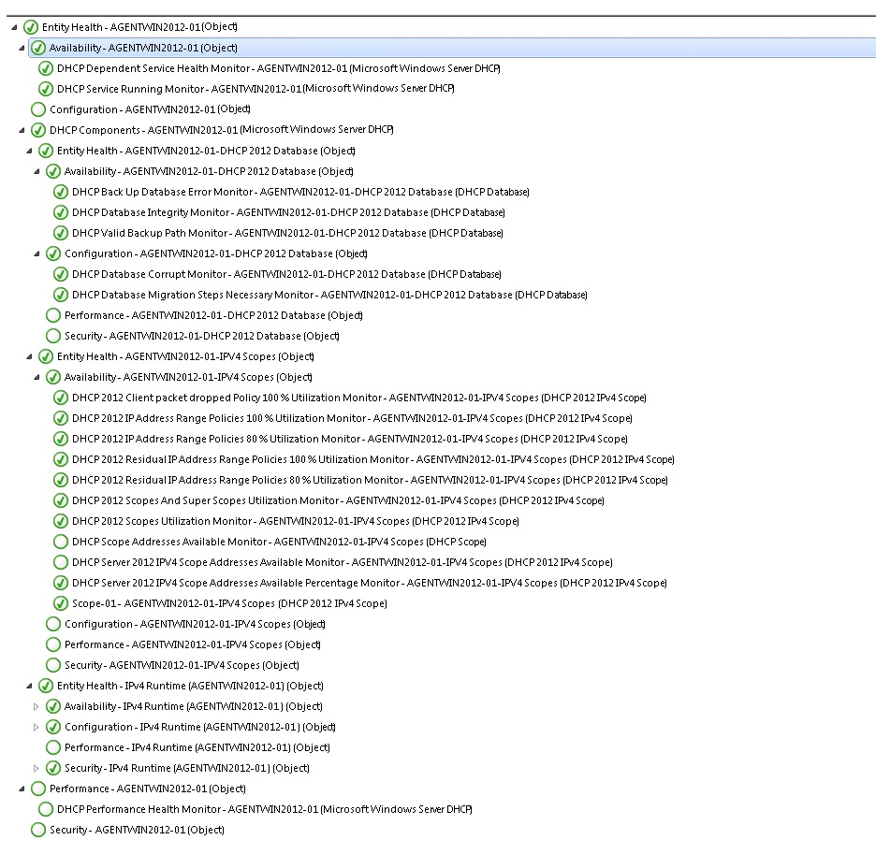

As per the above example: Since the “Unable to establish AD authorization” monitor is unhealthy/critical that is with the error. The container containing that monitor which is “Availability” is as well unhealthy/critical and so on that is the next higher level container is unhealthy/critical as captured above.

Following is the list of monitors and their health states in the Management Pack:

DHCP 2012 Server:
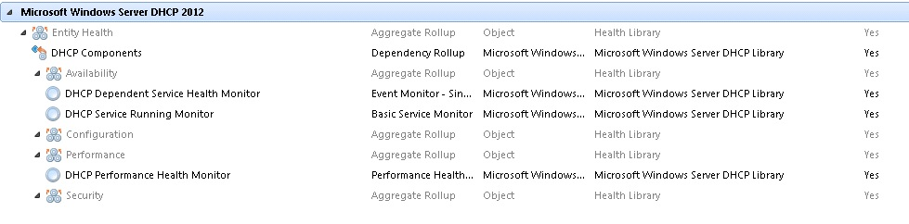
DHCP Database:
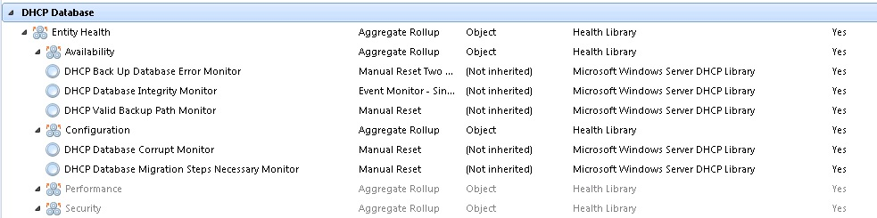
DHCP IPV4 Runtime:
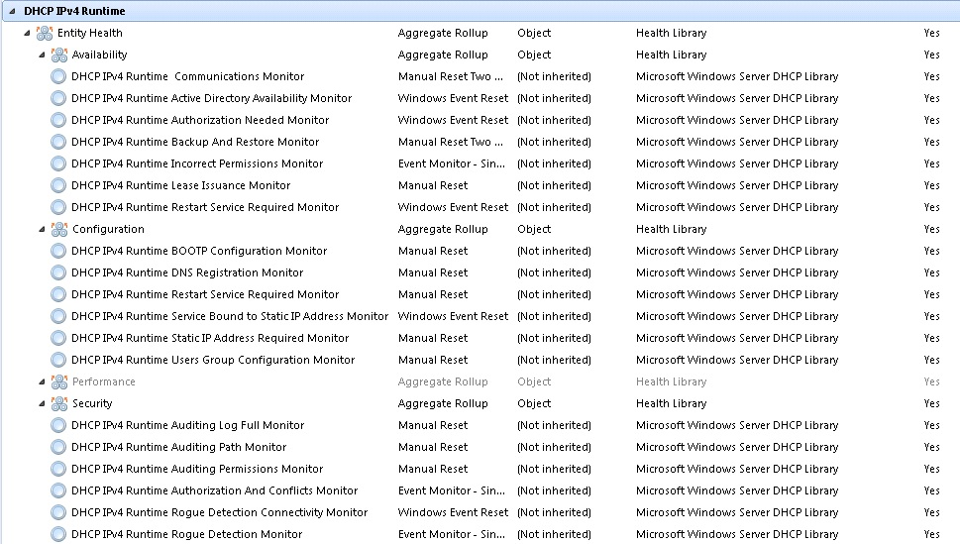
DHCP IPV6 Runtime:
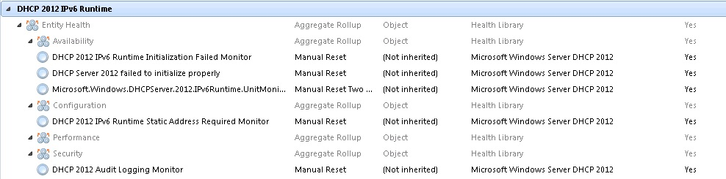
DHCP IPV4 Scope:
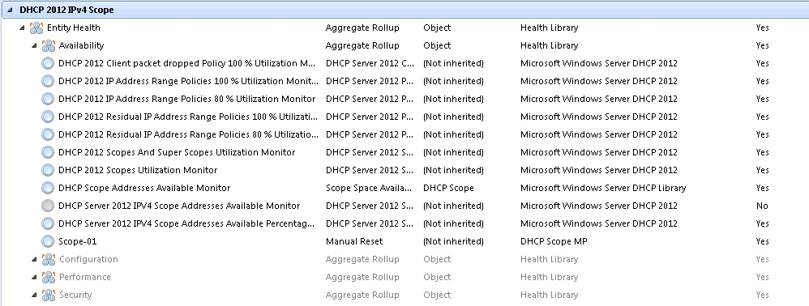
DHCP IPV6 Scope:
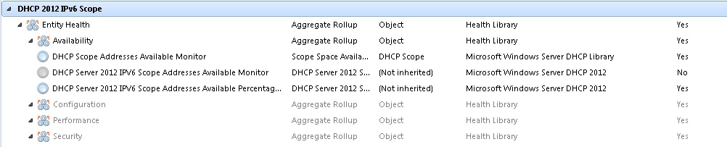
DHCP Failover Server Relationships:
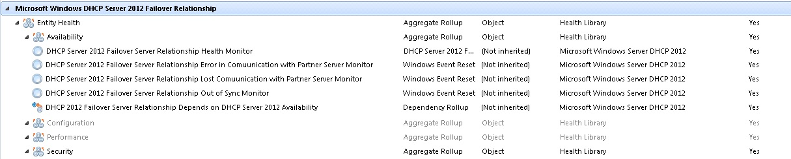

Key Monitoring Scenarios
The Windows Server DHCP Management Pack for System Center Operations Manager 2012 includes a number of key monitoring scenarios that are configurable.

Scenario | Description
DHCP Server Health | This server-centric view monitors the health, availability, security, and configuration of all DHCP components. This view also rolls up status through the use of aggregate monitors.  • Is this DHCP server functioning?  • Do all DHCP scopes have sufficient remaining IP addresses to hand out?
DHCP Service Health | This service-wide view monitors the health, availability, security, and configuration of all DHCP components and rolls up status through the use of aggregate monitors.  • Are all my DHCP servers currently healthy across the enterprise?
DHCP Core Component Health | Is DHCP ready to serve clients?  • The DHCP service is running.  • It is bound to all defined network cards.  • It is authorized properly in the Active Directory service.
DHCP Database Health | Are the DHCP databases healthy?  • Able to load all scope and Super scopes.  • Enough disk space available for database use.  • Database is not corrupted.
DHCP Security Health (Windows Server 2012) | • Are any security-related issues occurring?  • Is the DHCP service performing secure updates to the Domain Name System (DNS)?  • Does the DHCP server detects any rogue servers?
DHCP Security Health (Windows Server 2012 R2) | • Are any security-related issues occurring?  • Is the DHCP service performing secure updates to the Domain Name System (DNS)?  • Does the DHCP server detects any rogue servers?
DHCP Performance Health | • Are the DHCP server queues healthy?  • Are the DHCP servers responding to all queries in a timely manner?
DHCP Configuration Changes | • Detects any configuration changes. Optional ability to alert on changes.  • Configuration reports show any inconsistent settings across the enterprise so that users can correlate those inconsistencies to service-related issues.
DHCP Performance Counter Collection | Provides the ability to chart and report on historical performance.
DHCP Policies | Are the defined policies for Scopes healthy?
DHCP Cluster and Failover Server Relationships | Are the partner server communication is up?  Are the clustered nodes are running healthy?

Known Issues and Troubleshooting
Known Issue: Discoveries fail on agents without PowerShell
Issue: Discoveries will fail on the agents without PowerShell installed on the server.
Workaround: Install PowerShell, or disable “DHCP Cluster 2012 Server Discovery Data Source” and “DHCP 2012 Server Discovery Data Source” discoveries on these agents. Then, run the following command in the “Operations Manager Shell”: Remove-SCOMDisabledClassInstance.
Known Issue: “DHCP IPV4 scope” is deprecated; several rules and monitors are deprecated
Issue: As long as "DHCP IPV4 scope" is deprecated, the following rules and monitors are deprecated:
- Collect IPv4 DHCP Client Declines Events
- Collect IPv4 NACK Issued Events
- Collect IPv4 Scope Full Events
- Collect Unknown IPv4 Option Events
- Collect IPv4 Boot Full Events
- Collect IPv4 Released Leases
- Collect Orphaned Entries Deleted Events
- Collect IPv4 Low Address Warning Events
- DHCP IPv4 Scope BOOTP Full Monitor
- DHCP IPv4 Scope NACKs Occurring Monitor
- DHCP IPv4 Scope Reconcile Required Monitor
- DHCP IPv4 Scope Unknown Option Monitor
Workaround: No workaround available.
Known Issue: "IPv6 Binding Is Enabled" and "IPv6 Preferred Lifetime" properties are not populated
Issue: “IPv6 Binding Is Enabled” and “IPv6 Preferred Lifetime” properties are not filled with the corresponding values.
Workaround: No workaround available.
Known Issue: DHCP server role is discovered on all cluster virtual servers
Issue: DHCP server role is discovered on all cluster virtual servers. Therefore, all cluster groups are found as DHCP servers.
Workaround: Disable “DHCP Cluster 2012 Server Discovery Data Source” discovery for all agentless cluster computers except for cluster virtual servers, which represent clustered DHCP role. Then, run the following command in the “Operations Manager Shell”: Remove-SCOMDisabledClassInstance.
Known Issue: Non-clustered DHCP server roles are discovered on active clustered node
Issue: Discovery finds non-clustered DHCP roles on clustered node, which owns DHCP role.
Workaround: Disable “DHCP 2012 Server Discovery Data Source” discovery for all agentless computers, which are located on a cluster having clustered DHCP role. Then, run the following command in the “Operations Manager Shell”: Remove-SCOMDisabledClassInstance.
Known Issue: Discoveries fail on Nano server 2012
Issue: “DHCP Cluster 2012 Server Discovery Data Source” and “DHCP 2012 Server Discovery Data Source” discoveries fail on Nano servers 2012.
Workaround: Disable “DHCP 2012 Server Discovery Data Source” discovery for “Windows Server 2012 Computer (Nano)” class. Disable “DHCP Cluster 2012 Server Discovery Data Source” discovery for clustered nodes on Nano server 2012. Then, run the following command in the “Operations Manager Shell”: Remove-SCOMDisabledClassInstance.
Known Issue: "DHCP server 2012 discovery data source" fails if DHCP server is not running
Issue: "DHCP server 2012 discovery data source" fails if DHCP server is not running.
Workaround: No workaround available.
Known Issue: "Discovery DHCP 2012 Failover Server Relationships Data Source" does not work
Issue: "Discovery DHCP 2012 Failover Server Relationships Data Source" does not work if partner server name is set as IP address.
Workaround: Check that agent is installed on all DHCP servers in Failover Relationship. And then setup DHCP Failover partner(s) with FQDN instead of IP address.
Another option: during creation of failover relationship via "DHCP Manager" console, use DNS name of servers. For remote servers, use "Add-DhcpServerv4Failover" PowerShell cmdlet instead of remote connection via "DHCP Manager" console.
For example:
"Add-DhcpServerv4Failover -ComputerName base1-core-01.baseos1.local -Name CORE01toCORE02 -PartnerServer base1-core-02.baseos1.local -ScopeId 192.168.241.0"
Known Issue: "Discovery DHCP 2012 Failover Server Relationships Data Source" fails if DHCP failover returns empty data for some properties
Issue: Discovery may fail if DHCP failover returns empty data for some properties.
Workaround: No workaround available.
Display Strings Known Issue: "Ping IPV4 Scope" and " Ping IPV6 Scope" tasks have incorrect output
Issue: The tasks output displays grammatically incorrect text ("is a invalid ip") and does not display the required data.
Workaround: No workaround available.
Known Issue: For “DHCP 2012 Server Discovery Data Source Discovery”, data type of "IPv6 valid lifetime"/"IPv6 IATA valid lifetime" properties is incorrect
Issue: For “DHCP 2012 Server Discovery Data Source discovery”, data type of "IPv6 valid lifetime"/"IPv6 IATA valid lifetime" properties is incorrect; the data in SCOM is rounded to the nearest integer.
Workaround: No workaround available.
Known Issue: Incorrect populating of binding properties of DHCP server
Issue: If DHCP server has more than one Network Adapters, than the property is populated from the second Adapter.
Workaround: No workaround available.
Known Issue: “Warning” state of “DHCP Dependent Service Health Monitor” does not work
Issue: “Warning” state of “DHCP Dependent Service Health Monitor” does not work as long as it’s deprecated.
Workaround: No workaround available.
Display Strings Known Issue: Several non-alerting rules have empty "Product Knowledge"
Issue: The following non-alerting rules have empty "Product Knowledge":
- Collect DHCP Database Cleanup Events
- Collect DHCP Callout Loading Success Events
- Collect DHCP Network Failure Events
- Collect DHCP Database Backup Path Failure Events
- Collect DHCP Database Cleanup Complete Events
- Collect DHCP Database Cleanup Started Events
- Collect DHCP Database Conversion In Progress Events
- Collect DHCP Database Conversion Required Events
- Collect DHCP Database Backup Failure Events
- Collect DHCP Database Load Failure Events
- Collect DHCP Database Path Failure Events
- Collect DHCP Database Initialization Failure Events
- Collect DHCP Jet Error Events
- Collect DHCP Database Warning Events
- Collect DHCP Database Restore Complete Events
- Collect DHCP Database Restore Failure Events
- Collect DHCP Audit Log Append Failure Events
- Collect DHCP Audit Log Intiialization Failure Events
- Collect DHCP Audit Log Move Failure Events
- Collects DHCP Authorized And Started Events
- Collect DHCP Bad Audit Path Events
- Collect DHCP BOOTP File Table Read Failure Events
- Collect DHCP Callout Load Exception Events
- Collect DHCP Callout Load Failure Events
- Collect Client Cleanup Events
- Collect DHCP Registry Configuration Backup Error Events
- Collect DHCP Local Users Group Failure Events
- Collect DHCP Domain Authorized Events
- Collect DHCP Domain Authorized And Started Events
- Collect DHCP Can't Locate Domain Events
- Collect DHCP Domain Not Authorized Events
- Collect DHCP Domain Unauthorized Events
- Collect DHCP Domain Authorization Unchecked Events
- Collect DHCP Domain Recently Upgraded Events
- Collect DHCP Failed To Locate a DC Events
- Collect DHCP Dynamic Address Detected Events
- Collect DHCP BOOTP Global Filename Read Failure Events
- Collect DHCP Configuration Initialization Failure Events
- Collect DHCP Interface Notification Failed Events
- Collect DHCP Other Server Detected Events
- Collect DHCP Ping Failure Events
- Collect DHCP Registry Restore Failure Events
- Collect Rogue DHCP Server Detected Events
- Collect DHCP Recently Upgraded Events
- Collect Winsock Failed Events
- Collect DHCP Callout Failure Events
- Collect DHCP Not Authorized Events
- Collect DHCP Unauthorized Events
- Collect Incorrect DNS Credentials Events
- Collect No DNS Credentials on DC Events
- Collect SBS DHCP Detected Other DHCP Server Events
- Collect IPv4 DHCP Client Declines Events
- Collect IPv4 Low Address Warning Events
- Collect IPv4 NACK Issued Events
- Collect IPv4 Scope Full Events
- Collect Unknown IPv4 Option Events
- Collect IPv4 Boot Full Events
- Collect IPv4 Released Leases
- Collect Orphaned Entries Deleted Events
- Collect DDNS Update Request Events
- Collects DDNS Update Successful Events
- Collect DHCP Initialized and Ready
- Collect DHCP not bound to static IP address
- Collect Init Data Failed Events
- Collect Init Registry Failed Events
- Collect Registration Failure Events
- Collect Init RPC Failed Events
- Collect Script Trace Events
- Collect Winsock Failed Events
- DHCP Back Up Database Error Rule
- Collect All DHCP Server Performance Data
- Collect Scope Free Addresses
- Collect Scope Addresses In Use
- Collect DHCP Acks / Second
- Collect DHCP Active Queue Length
- Collect DHCP Conflict Check Queue Length
- Collect DHCP Declines / Second
- Collect DHCP Discovers / Second
- Collect DHCP Duplicates Dropped / Second
- Collect DHCP Informs / Second
- Collect DHCP Average Milliseconds / Packet
- Collect DHCP Nacks / Second
- Collect DHCP Offers / Second
- Collect DHCP Packets Expired / Second
- Collect DHCP Packets Received / Second
- Collect DHCP Releases / Second
- Collect DHCP Requests / Second
- Collect Free Superscope Addresses
- Collect Superscope Addresses In Use
Workaround: No workaround available.
Known Issue: "DHCP Scopes MONITORING FAILS FOR LARGE NUMBER OF SCOPES”
Issue: DHCP 2012 MP workflows cause CPU spike when there are over 1000+ DHCP Scopes and causes the monitoring to crash.
Workaround: Disable the Rules and Monitors on scopes and create a Group for inclusion list i.e. add priority scopes to the group and enable the monitors and rules to run only on the group.
Known Issue: "DHCP Scope Addresses Available Monitor FAILS FOR LARGE NUMBER OF SCOPES”
Issue: DHCP Scope Addresses Available Monitor causes CPU spike when there are over 1000+ DHCP Scopes and causes the monitoring to crash.

Workaround: Added New monitor “Microsoft Windows Server DHCP 2012 Scope Addresses Availability” for monitoring all the scopes as a single unit and task for generating critical scopes report.

- After importing the MP, first disable the scopes discovery using the task “Disable DHCP IPv4 Scopes Discovery” on “DHCP 2012 IPv4 Scopes”, by providing, ID of any un-sealed MP as input for storing overrides.
- Then enable the “DHCP IPv4 Scopes Runtime Discovery”
- Then on “DHCP 2012 IPv4 Scopes Runtime” class new “Microsoft Windows Server DHCP 2012 Scope Addresses Availability” will be running and we can run the Task “Critical Scopes Availability” on same class to get list of all critical scopes.
- For the task “Critical Scopes Availability” if Destination Server is different from agent server then provide the Destination Server credentials in Task credentials.

Links
The following links connect you to information about common tasks that are associated with System Center management packs:
System Center 2012 - Operations Manager

• Management Pack Life Cycle
• How to Import a Management Pack
• Tuning Monitoring by Using Targeting and Overrides
• How to Create a Run As Account
• How to Export a Management Pack
• How to Remove a Management Pack
Operations Manager 2007 R2

• Administering the Management Pack Life Cycle
• How to Import a Management Pack in Operations Manager 2007
• How to Monitor Using Overrides
• How to Create a Run As Account in Operations Manager 2007
• How to Modify an Existing Run As Profile
• How to Export Management Pack Customizations
• How to Remove a Management Pack
For questions about Operations Manager and management packs, see the System Center Operations Manager community forum.
A useful resource is the System Center Operations Manager Unleashed blog, which contains “By Example” posts for specific management packs.
For additional information about Operations Manager, see the System Center 2012 - Operations Manager Survival Guide and Operations Manager 2007 Management Pack and Report Authoring Resources
Important
All information and content on non-Microsoft sites is provided by the owner or the users of the website. Microsoft makes no warranties, express, implied, or statutory, as to the information at this website

